**Project Report**

**Tracing the growth of the global community: A population forecasting analysis**

1. **INTRODUCTION**
   1. Overview

The world’s population is more than three times larger than it was in the mid-twentieth century. The global human population reached 8.0 billion in mid-November 2022 from an estimated 2.5 billion people in 1950, adding 1 billion people since 2010 and 2 billion since 1998. The world’s population is expected to increase by nearly 2 billion persons in the next 30 years, from the current 8 billion to 9.7 billion in 2050 and could peak at nearly 10.4 billion in the mid-2080s. This dramatic growth has been driven largely by increasing numbers of people surviving to reproductive age, the gradual increase in human lifespan, increasing urbanization, and accelerating migration. Major changes in fertility rate have accompanied this growth. These trends will have far-reaching implications for generations to come.

* 1. Purpose

Population growth is one of the major concerns of the present world as the human population is not a static factor. Rather, it is growing at a very alarming rate. In spite of the increasing world population, the resources of the earth remain constant. Thus, the ability to maintain sustainable development is becoming a major challenge to mankind today. All nations are committed to achieving a higher standard of living for their people—adequate food, good health, literacy, education, and gainful employment. These are the goals of millions now living in privation. An important barrier to the achievement of these goals is the current rate of population growth. Such rapid population growth, which is out of proportion to present and prospective rates of increase in economic development, imposes a heavy burden on all efforts to improve human welfare. Moreover, since we live in an interconnected world, it is an international problem from which no one can escape. The purpose of the project is to trace the population growth over the past years. With the collected dataset, we have done analysis using MySQL and Tableau. From the visualisations created using Tableau, one can understand, explore the information and complex data sets are made more accessible, intuitive, & easier to interpret. These visualizations can be used to compare performance, track changes over time, show distribution, and relationships between variables. Due to population forecasting analysis, we can be able to fulfil future requirements and practice sustainability as per needs.

Social Impact: Improve the infrastructure and strategies through which the cities could manage the population

Business Model/Impact: Improved strategic planning: By understanding population growth trends and demographics, a business can make more informed decisions about where to invest resources and expand operations.

1. **PROBLEM DEFINITION AND DESIGN THINKING**
   1. Empathy map
   2. Ideation & Brainstorming map
2. **RESULT**

Dashboards: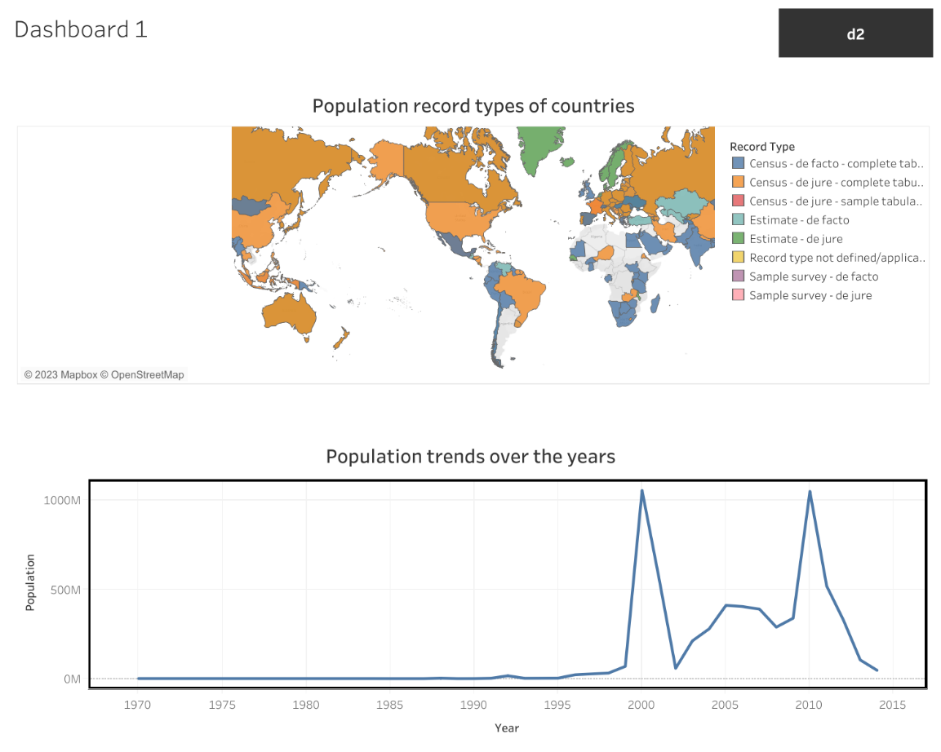

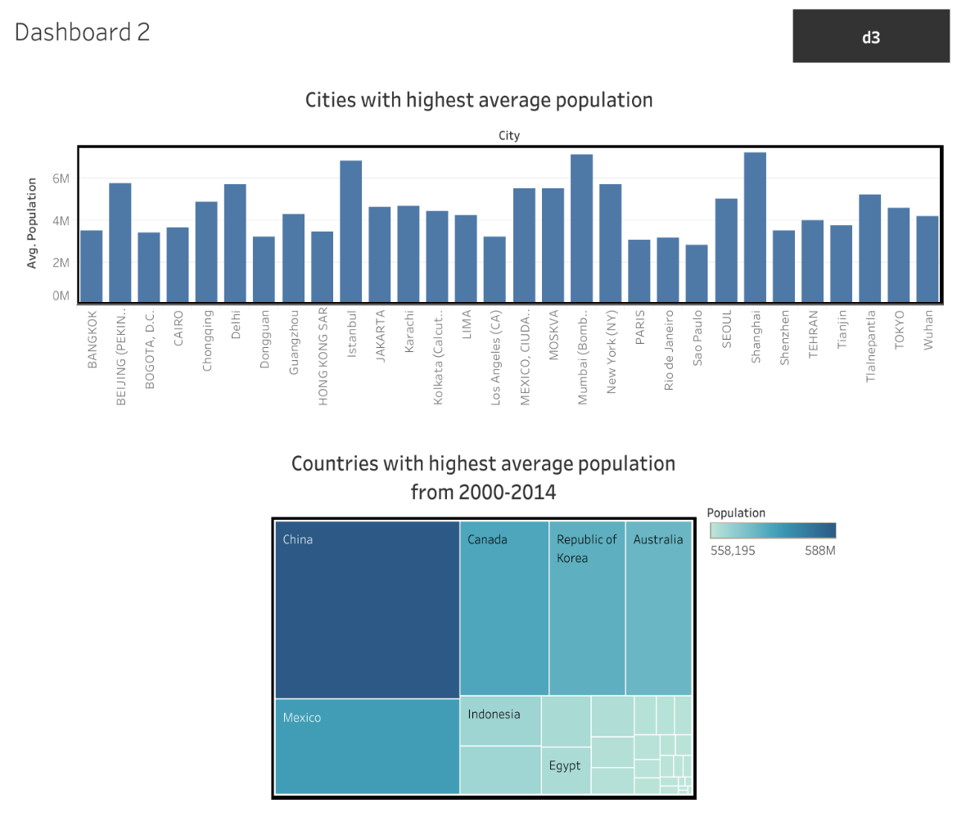

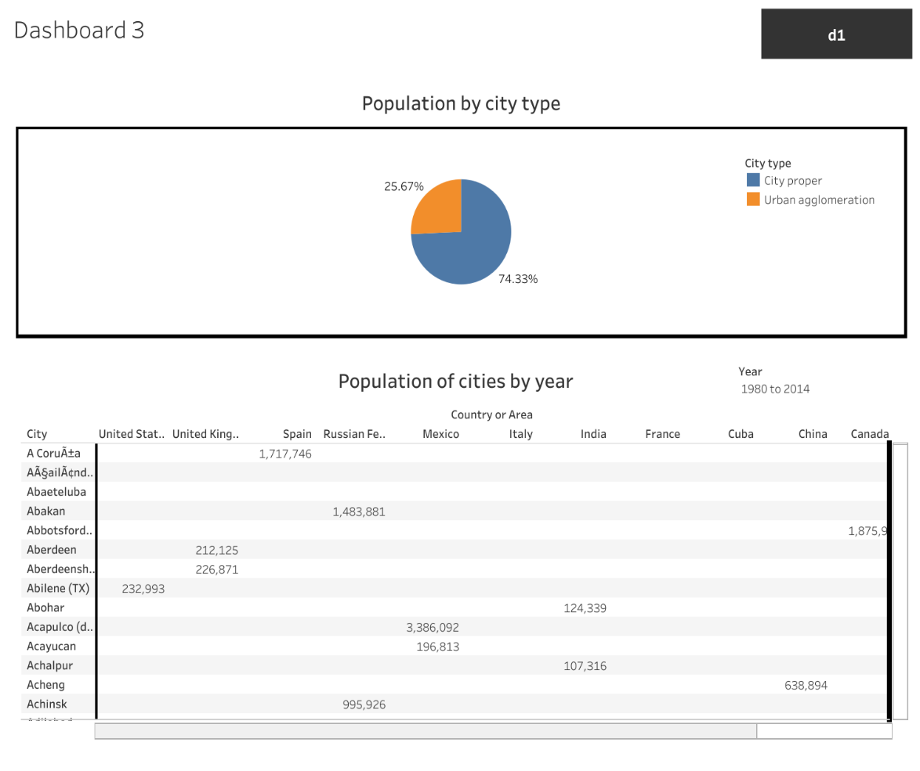

1. **ADVANTAGES AND DISADVANTAGES**

|  |  |
| --- | --- |
| Advantages | Disadvantages |
| Increased human capital | Congestion |
| Increased tax revenues/economic growth | Energy crisis |
| More scope for innovation, invention | Eco degradation |
| Increased diversity | Problem of unemployment |
| Increased productivity through specialisation | Water shortages |
| Economies of scale | Pressure on environment |
| Critical mass | Standard of living |

1. **APPLICATIONS**

Populations are never static, they grow or decline through the interplay of three demographic processes:

1. Fertility  
   Number of births that occur to an individual or a population
2. Mortality  
   Death of an individual or the number of deaths that occur in a population
3. Migration  
   The movement of people into or out of a specific geographic area

Planners need to study changes in the composition of the population to plan for education, health care services, and economic development projects.

**Ways Population Analysis is Used in the Private and Public Sectors:**

**In private sector, planners**

* Identify profitable locations for goods and services
* Perform production analysis
* Develop advertising strategies
* Perform strategic planning

The private sector is basically concerned about the ‘demand’ and ‘location’ for products and services.

**In public sector**,

* Planners use population information to determine the demand of services among different segments of the population. Demand is determined by the composition of the population and how it is changing over time — age-sex distribution, martial status, household types, occupation distribution, spatial distribution of the population, educational levels and income levels.
* Planners also study the present and future composition of the population.
* Planners also examine population characteristics to determine the feasibility for new programs.
* Planners are also concerned about the impact of new plans on population change. A new plan to promote rural industries can lead to population growth as new families move into the community for job opportunities.
* Planners are also concerned about the impact of population growth on the ability to implement existing plans.

Demographic analysis in the planning process:

* Study trends in mortality rate, fertility, age-sex structure to identify problems and needs
* Collect information to establish goals and objectives
* Collect information on the size, location and composition of the target population to develop alternate strategies
* Collect demographic data to select and implement a plan of action
* Use of demographic indicators to measure the achievement of the objectives

1. **CONCLUSION**

Population analysis is needed to identify problems and community needs, establish goals and objectives, assess alternative courses of action, allocate resources for plan implementation, and evaluate the ability of the plan to achieve goals and objectives. To tackle the problem of rapid population growth, developing countries needs to take corrective measures. The government and various NGOs should raise awareness about family planning and welfare. The governments of developing countries should come forward to empower women and improve the status of women and girls. People in rural places should be educated and modern amenities should be provided for recreation.

1. **FUTURE SCOPE**

It is important to have high quality statistics on the population and projections of the population, for policy development and for planning and providing public services. It helps to understand the various facts about the spatial variation in the distribution of human population across the earth concerning the physical, cultural, and socio-economic environment. It also helps in the planning for human development.